LAB EXERCISE:

1. Write a simple "Hello World" program in two different programming languages of your choice. Compare the structure and syntax.

Ans.

=> C Program:

#include <stdio.h>

int main()
{
printf("Hello, World!\n");
return 0;
}

=> C++ Program:

#include <iostream>
int main()
{
std::cout << "Hello, World!" << std::endl;
return 0;
}

Comparison of Structure and Syntax:
- Header File Inclusion:
  - C: The program uses #include <stdio.h>, which is the standard library for input and output in C. It provides the printf function.
  - C++: The program uses #include <iostream>, which is the standard C++ library for input and output. It provides std::cout for outputting data.
- Main Function:
  - Both C and C++ programs start with the main() function, which is the entry point of the program. The main() function must return an integer value (0 typically indicates successful execution).
- Printing to the Console:
  - C: The program uses the printf() function to print text to the console. It's a part of the stdio.h library.
  - C++: The program uses the std::cout stream, which is part of the iostream library, and the << operator to send data to the output stream. Additionally, std::endl is used to insert a newline, which is similar to \n in C.
- Syntax Differences:
  - In C, functions like printf() are used for output. The code doesn't use namespaces, meaning functions like printf are called directly.
  - In C++, output uses std::cout, and C++ has the concept of namespaces (std:: is the standard namespace). The << operator is used to stream data to cout.
- Return Statement:
  - Both programs return 0 from the main() function, indicating successful execution. This is common in both languages.

2. Research and create a diagram of how data is transmitted from a client to a server over the internet.

Ans.

Data transmission from a client to a server over the internet involves several key steps and components. Here's an overview of the
process: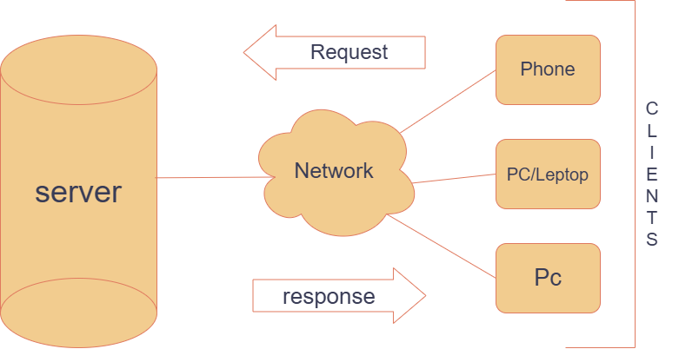

1. Client Request: The client initiates a request by sending data packets over the internet.

2. Network: A network is a system of interconnected entities—such as computers, servers, or other devices—that communicate 4. Research different types of internet connections (e.g., broadband, fiber, satellite) and list their pros and cons
with each other to share resources and information. In the context of information technology, a network enables devices to exchange data, access shared resources like printers or storage, and facilitate various forms of communication, including email, instant messaging, and video conferencing

3. Internet Routing: Routers along the internet's infrastructure determine the optimal path for each packet to reach the server.

4. Server Reception: The server receives the data packets, reassembles them into the original message, and processes the request.

5. Server Response: The server sends a response back to the client, following a similar process in reverse.

When selecting an internet connection, it's essential to understand the various types available, each with its own advantages and disadvantages. Here's an overview of common internet connection types:
1. Fiber-Optic Internet
Pros:
- High Speeds: Offers ultra-fast download and upload speeds, often up to 1 Gbps or higher.
- Reliability: Less susceptible to interference, providing a stable connection.
- Low Latency: Ideal for activities like online gaming and video conferencing.
Cons:
- Limited Availability: Not widely available in all areas, especially rural regions.
- Higher Costs: Installation and service fees can be more expensive compared to other types.
2. Cable Internet
Pros:
- High Speeds: Provides speeds up to 1 Gbps in some areas.
- Reliability: Generally stable, suitable for streaming and gaming.
- Availability: Widely available in urban and suburban areas.
Cons:
- Shared Bandwidth: Speeds may decrease during peak usage times due to shared infrastructure.
- Higher Costs: Service fees can be higher, especially when bundled with other services.
3. Digital Subscriber Line (DSL) Internet
Pros:
- Availability: Accessible in many areas, including rural regions.
- Cost-Effective: Generally more affordable than fiber and cable options.
Cons:
- Lower Speeds: Typically offers slower speeds compared to fiber and cable.
- Distance Sensitivity: Speed and reliability can degrade with distance from the provider's facility.

3. Design a simple HTTP client-server communication in any language.

Ans.

The image illustrates a basic client-server interaction using sockets over a TCP connection. Here's a breakdown of the process:

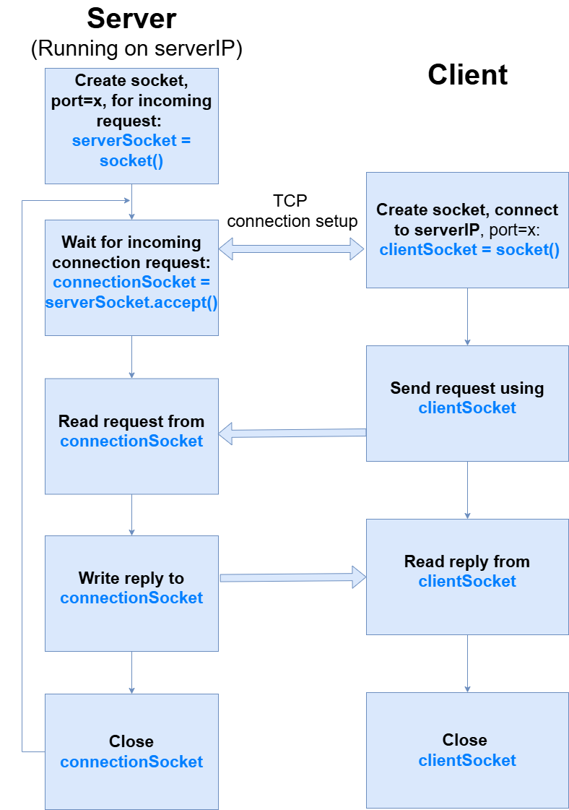
Server Side (Running on serverIP):

- Create a socket
  - The server creates a socket (serverSocket = socket()) and binds it to a specific port (x) to listen for incoming requests.
- Wait for an incoming connection request
  - The server listens for a client connection and accepts it using serverSocket.accept().
  - When a client connects, a new socket (connectionSocket) is created for communication.
- Read request from connectionSocket
  - The server receives data sent by the client.
- Write reply to connectionSocket
  - The server processes the request and sends a response back to the client.
- Close connectionSocket
  - The server closes the socket after sending the reply.

Client Side:

- Create a socket & connect to the server
  - The client creates a socket (clientSocket = socket()) and connects to the server at serverIP on port x.
- Send request using clientSocket
  - The client sends a request to the server through the socket.
- Read reply from clientSocket
  - The client waits for and reads the response from the server.
- Close clientSocket
  - The client closes the connection after receiving the response.

4. Research different types of internet connections (e.g., broadband, fiber, satellite) and list their pros and cons.

Ans.

1. Fiber Optic Internet
🔹 How it Works:
- Uses fiber-optic cables to transmit data as light signals, providing ultra-fast speeds.

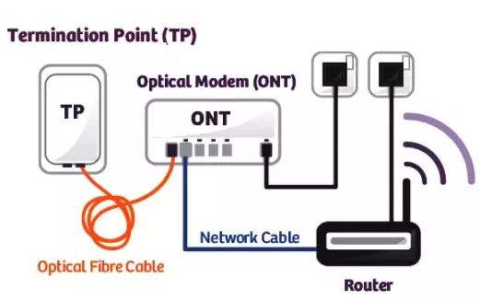

2. Broadband Connection:

Broadband refers to high-speed internet access that is faster than traditional dial-up access. It is provided through either cable or telephone composition. It does not require any telephone connection that’s why here we can use telephone and internet connection simultaneously. In this connection, more than one person can access the internet connection simultaneously.

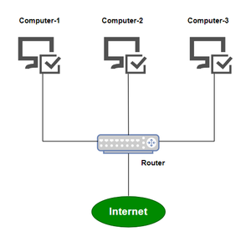

3. Satellite Connection:

This type of connection is provided mainly in rural areas where a broadband connection is not yet offered. It accesses the internet via a satellite that is in Earth’s orbit.
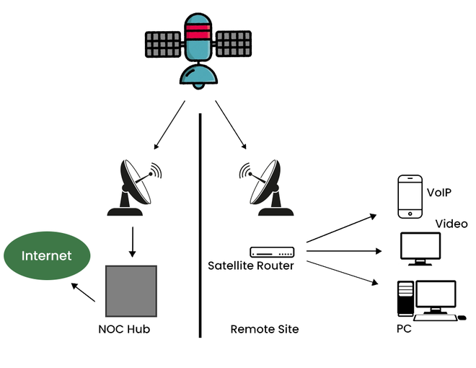

The signal travels from a long distance that is from earth to satellite and back again which provides a delayed connection. Satellite connection speeds range from 512k to 2.0Mbps.

5. Simulate HTTP and FTP requests using command line tools (e.g., curl).

Ans.
To simulate HTTP and FTP requests using command line tools like curl, follow these examples:

1. Simulating an HTTP request with curl
GET Request: To send a simple GET request (retrieve data) from a website:

curl https://www.example.com

This will retrieve the content of the specified URL and display it in the terminal.
POST Request: To send a POST request (submit data) to a server with some data:
curl -X POST https://www.example.com/api -d "key1=value1&key2=value2"

This will send an HTTP GET request with an Authorization header.
Save Output to a File: To save the output of a curl request to a file:
curl https://www.example.com -o filename.html

This saves the response content to a file called filename.html.

2. Simulating an FTP request with curl
Retrieve a File from an FTP Server: To download a file from an FTP server:
curl -u username:password ftp://ftp.example.com/path/to/file.txt -o downloaded_file.txt

Replace username and password with the correct FTP credentials, and ftp://ftp.example.com/path/to/file.txt with the correct FTP URL. This will download the file and save it as downloaded_file.txt.
Upload a File to an FTP Server: To upload a file to an FTP server:
curl -u username:password -T localfile.txt ftp://ftp.example.com/path/to/upload/

This uploads localfile.txt to the FTP server at the specified location.
List Files on an FTP Server: You can also list files in a directory on the FTP server:
curl -u username:password ftp://ftp.example.com/path/to/directory/

This lists the files in the specified FTP directory.

- Identify and explain three common application security vulnerabilities. Suggest possible solutions.

Here are three common application security vulnerabilities:
- SQL Injection (SQLi)

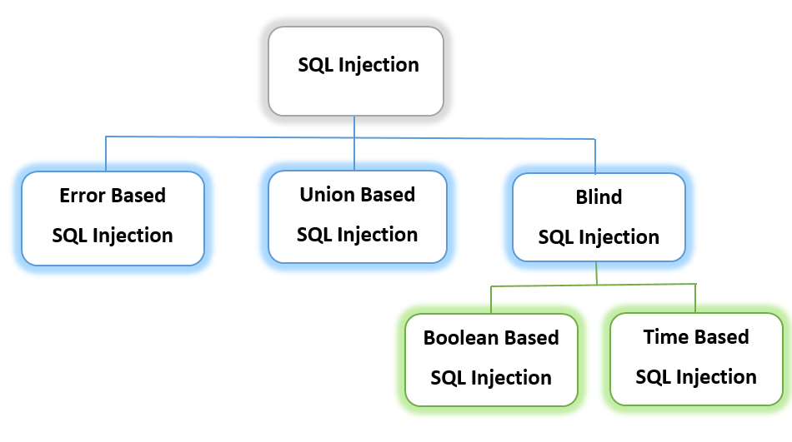
  - Explanation: SQL injection occurs when an attacker manipulates an application's SQL query by injecting malicious SQL code. This is possible when user inputs are not properly validated or sanitized.
  - Impact: Attackers can gain unauthorized access to databases, retrieve sensitive data, modify or delete records, and even take control of the application.
  - Prevention: Use parameterized queries, stored procedures, and input validation to sanitize user inputs.

- Cross-Site Scripting (XSS):

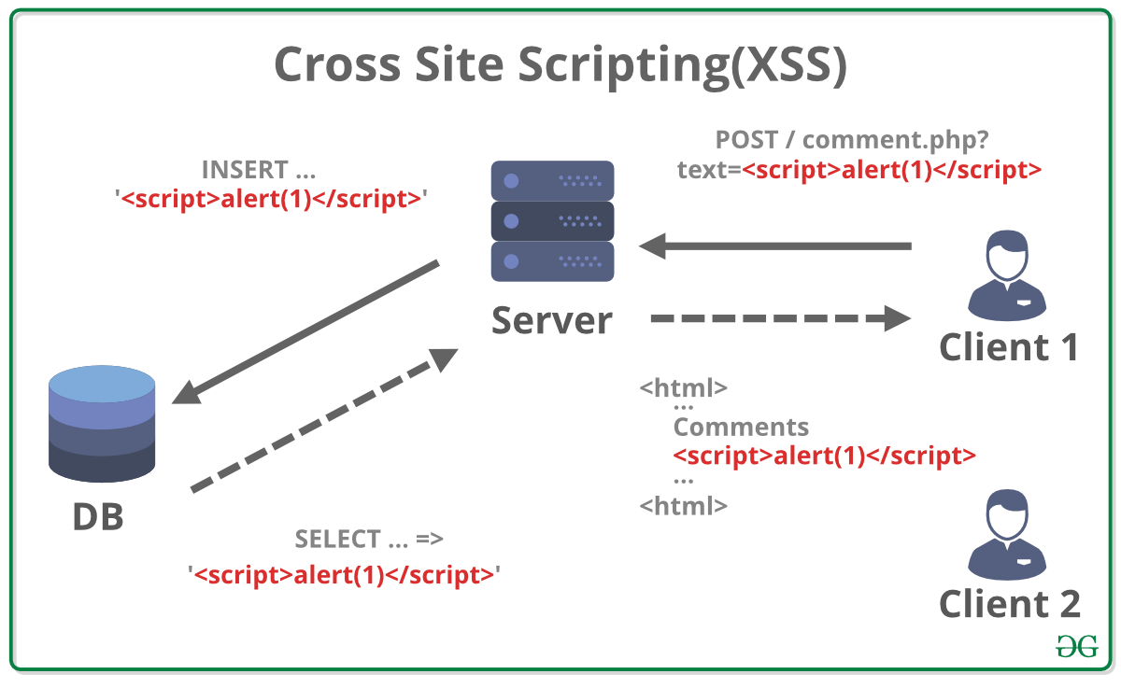

  - Explanation: XSS occurs when an application allows untrusted user input to be included in web pages without proper validation or escaping. Attackers can inject malicious scripts that execute in the browser of other users.
  - Impact: Attackers can steal cookies, session tokens, or other sensitive information, deface websites, and perform phishing attacks.
  - Prevention: Implement input validation, output encoding, and use security headers like Content Security Policy (CSP).

- Cross-Site Request Forgery (CSRF):

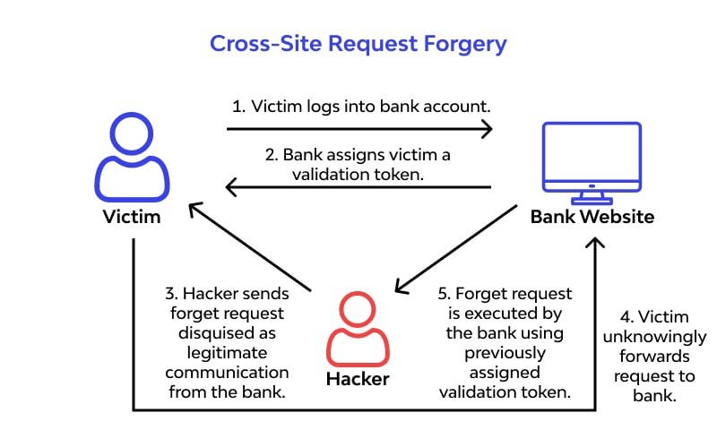

  - Explanation: CSRF tricks users into performing unintended actions on a web application in which they are authenticated. This happens when an attacker exploits a user's session by making unauthorized requests on their behalf.
  - Impact: Attackers can change user settings, make transactions, or perform administrative actions without the victim's consent.
  - Prevention: Use anti-CSRF tokens, require user authentication for sensitive actions, and implement same-site cookie attributes.

- Identify and classify 5 applications you use daily as either system software or application software.

1. System Software (Manages hardware & system operations)
Windows/macOS/Linux – Operating system managing computer resources.
Device Drivers – Software for printers, keyboards, or GPUs.
Antivirus Software – Protects against malware (e.g., Windows Defender).

2. Application Software (Performs specific tasks for users)
Google Chrome / Mozilla Firefox – Web browsers for internet access.
Microsoft Word / Google Docs – Word processors for document editing.
Spotify / YouTube – Media streaming applications for entertainment.
WhatsApp / Telegram – Messaging apps for communication.

- Design a basic three-tier software architecture diagram for a web application.

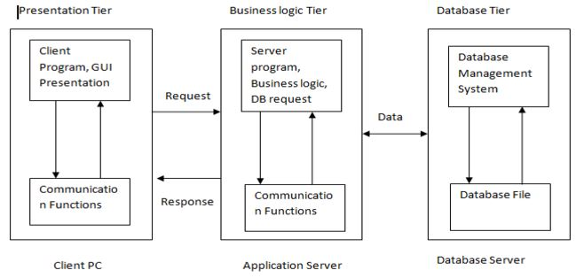

- Create a case study on the functionality of the presentation, business logic, and data access layers of a given software system.

Ans.
A multi-layered software architecture is used to separate concerns, improve maintainability, and enhance security in software systems. This case study explores the Presentation Layer, Business Logic Layer, and Data Access Layer in an E-Commerce System that allows users to browse products, add items to a cart, and complete purchases.



1. Presentation Layer (User Interface)
Functionality:
- This layer provides the front-end interface that users interact with.
- It displays product listings, shopping carts, and payment forms.
- It collects user input (e.g., login details, product selection) and sends requests to the business layer.
Example:
- A customer opens the website, searches for a product, and adds it to the cart.
- The UI (e.g., built with HTML, CSS, and JavaScript) sends the request to the business logic layer.

2. Business Logic Layer (Processing and Rules)
Functionality:
- Handles all rules, validations, and computations.
- Ensures correct processing of user requests (e.g., checking if an item is in stock).
- Communicates between the presentation and data access layers.
Example:
- When a customer adds a product to the cart, this layer checks stock availability, applies any discounts, and calculates the total price.
- If stock is available, it confirms the addition and updates the order details.

3. Data Access Layer (Database Interaction)
Functionality:
- Manages all database operations (retrieving, updating, and deleting data).
- Ensures secure data handling by preventing direct database access from the presentation layer.
- Uses SQL queries or ORM (e.g., Hibernate, Entity Framework) to interact with the database.
Example:
- When a customer places an order, this layer fetches product details, updates inventory, and stores the transaction record.
- The response is sent back to the business logic layer, which confirms the order and updates the UI

10.Explore different types of software environments (development, testing, production). Set up a basic environment in a virtual machine.

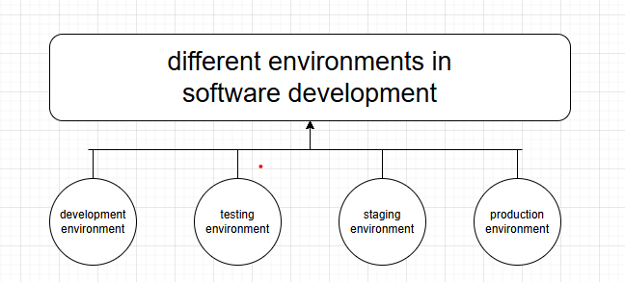

Software environments are categorized into three main types:
- Development Environment
  - Used by developers to write, test, and debug code.
  - Includes IDEs (e.g., VS Code, PyCharm), local databases, and version control tools.
  - Example: A local machine running Python, Node.js, or Docker for containerized apps.
- Testing Environment
  - Used to test applications before deployment.
  - Includes automated testing frameworks (e.g., Selenium, JUnit) and CI/CD pipelines.
  - Example: A separate VM or cloud instance with test datasets and mock services.
- Starting environment:
A development environment is a setup where software developers write, test, and debug their code. It typically includes tools such as code editors or integrated development environments (IDEs), compilers or interpreters, version control systems, and other utilities that facilitate the development process. This environment is isolated from production to ensure that any changes or experiments do not affect the end users.

- Production Environment
  - The live system where users interact with the software.
  - Requires high availability, security, and monitoring tools.
  - Example: A cloud server (AWS, Azure) or an on-premise data center.

11.Write and upload your first source code file to Github.

To the right of the page, select the Add file dropdown menu.

From the dropdown menu, click Upload files.

On your computer, open the folder containing your work, then drag and drop all files and folders into the browser.

At the bottom of the page, under "Commit changes", select "Commit directly to the main branch, then click Commit changes.

12. Create a Github repository and document how to commit and push code changes.

- In the upper-right corner of any page, select , then click New repository.
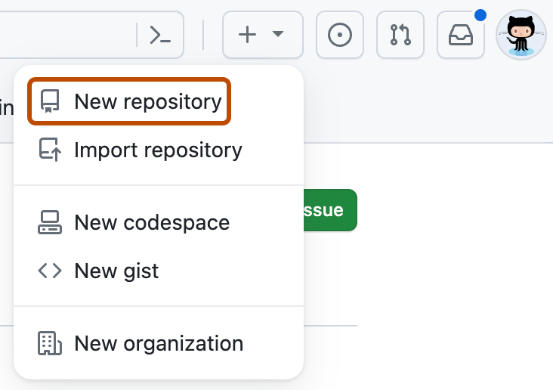
- In the "Repository name" box, type a name for your project. For example, type "my-first-project."
- In the "Description" box, type a short description. For example, type "This is my first project on GitHub."
- Select whether your repository will be Public or Private. Select "Public" if you want others to be able to see your project.
- Select Add a README file. You will edit this file in a later step.
- Click Create repository.

=>Make Changes and Commit
- Open the cloned repository folder on your computer.
- Make your changes using any text editor or IDE.
- Open GitHub Desktop, and it will detect your changes automatically.
- In the "Changes" tab, enter a commit message describing your changes.
- Click "Commit to main" to save the changes locally.

=>Push Changes to GitHub :
- In GitHub Desktop, click "Push origin" (top-right).
- Your changes will be uploaded to GitHub.
- Go to your repository on GitHub.com to see the updated files.

13. Create a student account on Github and collaborate on a small project with a classmate.

Step 1: Create a GitHub Student Account
- Go to GitHub and sign up using your email.
- Verify your email and complete the setup process.
- (Optional) Apply for the GitHub Student Developer Pack for free tools:
  - Visit GitHub Education.
  - Click "Get benefits" and provide proof of student status.
  - Wait for approval.

Step 2: Create a Repository
- Log in to GitHub.
- Click the "+" (plus icon) in the top-right corner → "New repository".
- Fill in the details:
  - Repository Name (e.g., student-collab-project).
  - Select "Public" or "Private".
  - Check "Initialize this repository with a README".
- Click "Create repository".

Step 3: Invite Your Classmate as a Collaborator
- Go to the repository page.
- Click "Settings" (at the top).
- In the left menu, select "Collaborators" (under "Manage Access").
- Click "Add people", enter your classmate’s GitHub username or email, and send an invite.
- Your classmate must accept the invitation from their email or GitHub notifications.

Step 4: Install and Use GitHub Desktop
- Download GitHub Desktop and install it.
- Open GitHub Desktop and sign in to GitHub.
- Click "Clone a repository" → Select the repository you created → Click "Clone".
- The project will be saved to your local computer.

Step 5: Make Changes & Push to GitHub (Without Command Line)
- Open the project folder on your computer.
- Make changes (e.g., create or edit a file in Notepad, Word, or any editor).
- Open GitHub Desktop:
  - You will see a list of changed files.
  - Add a commit message (e.g., "Updated README").
  - Click "Commit to main".
  - Click "Push origin" to upload changes to GitHub.

Step 6: Classmate Collaborates on the Project
- Your classmate should open GitHub Desktop, click "Fetch Origin", and pull the latest changes.
- They can make their changes, commit them in GitHub Desktop, and push them back.

14. Create a list of software you use regularly and classify them into the following categories: system, application, and utility software.

1. System Software (Manages hardware & provides a platform for applications)
- Operating System: Windows, macOS, Linux
- Device Drivers: Graphics Driver (NVIDIA, AMD), Printer Driver, Audio Driver
- Firmware: BIOS/UEFI, Router Firmware
- Virtualization Software: VMware, VirtualBox

2. Application Software (Used for specific tasks by users)
- Web Browsers: Google Chrome, Mozilla Firefox, Microsoft Edge
- Office Suite: Microsoft Office (Word, Excel, PowerPoint), Google Docs
- Communication: Zoom, Microsoft Teams, Slack
- Multimedia: VLC Media Player, Adobe Photoshop, Spotify
- Development Tools: Visual Studio Code, PyCharm, Android Studio
- Gaming: Steam, Epic Games Launcher, Xbox App

3. Utility Software (Helps maintain and optimize system performance)
- Antivirus & Security: Windows Defender, Norton, Malwarebytes
- Backup & Recovery: Google Drive, OneDrive, Acronis
- Disk Management: CCleaner, WinRAR, Disk Cleanup
- File Management: WinRAR, 7-Zip, FileZilla
- System Monitoring: Task Manager, HWMonitor, CPU-Z

15. Follow a GIT tutorial to practice cloning, branching, and merging repositories.

Clone a Repository Using GitHub Desktop
- Install GitHub Desktop and sign in.
- Click "File" > "Clone repository".
- Choose "GitHub.com" and select an existing repository (or create one on GitHub first).
- Click "Clone" and select a folder to store the repository locally.

Create a New Branch :
- Open GitHub Desktop.
- In the top bar, click the "Current branch" dropdown.
- Click "New branch", enter a name (e.g., feature-branch), and click "Create branch".
- Now, you’re working on the new branch.

Merge the Pull Request :
- Review the changes.
- Click "Merge pull request".
- Confirm by clicking "Confirm merge".
- (Optional) Click "Delete branch" to remove the feature branch after merging.

16. Write a report on the various types of application software and how they improve productivity.

Ans.
Application software helps users work faster, more efficiently, and with fewer errors. It automates tasks, simplifies complex processes, and improves communication. Here’s how different types of software enhance productivity:

- Automation of Repetitive Tasks
  - Example: Spreadsheet software like Excel automates calculations, reducing manual effort.
  - Benefit: Saves time and reduces errors in financial and data analysis.

- Better Organization and Data Management
  - Example: Database software like Microsoft Access stores and organizes information systematically.
  - Benefit: Quick data retrieval, reducing time spent searching for information.

- Improved Communication and Collaboration
  - Example: Communication tools like Zoom, Slack, and Microsoft Teams enable real-time collaboration.
  - Benefit: Teams can work together remotely, increasing efficiency.

- Enhanced Creativity and Presentation
  - Example: Graphics software like Photoshop and Canva helps in content creation.
  - Benefit: High-quality visuals improve marketing and branding efforts.

- Effective Project and Time Management
  - Example: Project management tools like Trello and Asana help track tasks.
  - Benefit: Keeps projects organized, ensuring deadlines are met.

Application software makes work easier by automating tasks, improving accuracy, enhancing communication, and increasing efficiency. This leads to higher productivity and better results in both personal and professional tasks.

17. Create a flowchart representing the Software Development Life Cycle (SDLC).

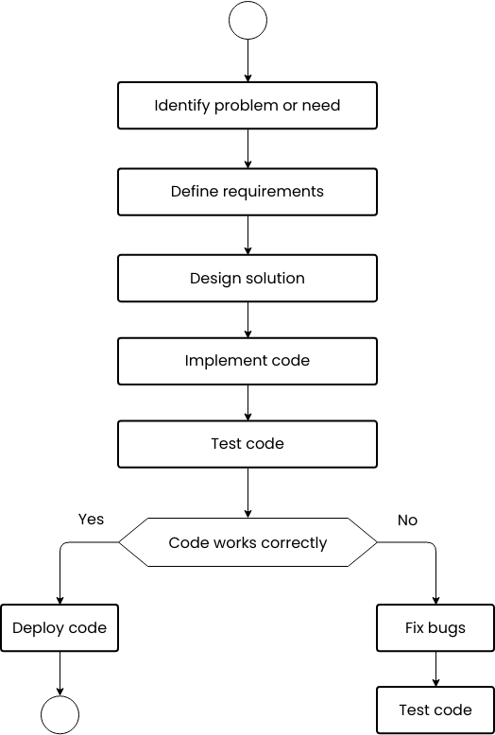

18. Write a requirement specification for a simple library management system.

A Library Management System is a software that helps a library manage books, members, and borrowing activities efficiently.
1. Users of the System:
- Librarian: Adds books, manages members, issues and returns books, and generates reports.
- Library Member: Searches for books, borrows and returns books, and checks borrowing history.

2. Main Features:
- Book Management: Add, update, remove, and search books.
- Membership Management: Register, update, or deactivate members.
- Borrow & Return: Track issued books, set due dates, and apply fines for late returns.
- Reports & Notifications: Generate reports on book status and send alerts for due dates.

3. Other Requirements:
- Easy to use with a simple interface.
- Secure login for librarians and members.
- Fast performance for book searches and transactions.
- Scalable to support more books and users in the future.

4. Limitations:
- Needs a database to store book and member details.
- Requires internet for online access.
- Only authorized staff can manage system settings.

This system helps librarians and members efficiently manage books, borrowing, and returning processes, making library operations smoother and faster.

19. Perform a functional anaysis for an onine shopping system.

​ ​A functional analysis of an online shopping system involves identifying and detailing the essential functions that enable users to browse, select, purchase, and manage products or services through a digital platform. This analysis ensures that all necessary components are in place to provide a seamless shopping experience.
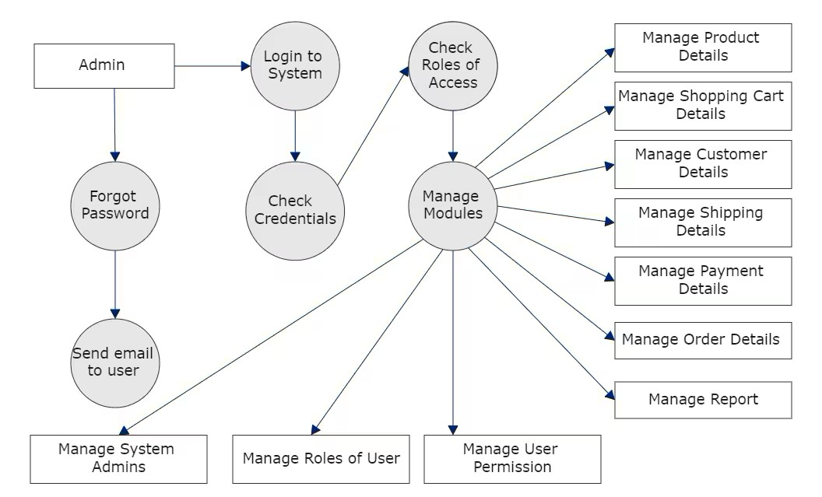

1. Admin Authentication & Management
- The admin logs into the system.
- If the admin forgets the password, a recovery email is sent.
- The system checks credentials before granting access.
- Admins can manage system administrators.

2. Role & Permission Management
- The system verifies the admin’s role-based access.
- Admins can assign different roles to users.
- User permissions can be modified to control system access.

3. Core System Modules
- The Manage Modules function allows the admin to oversee different operational components:
  - Product Management: Adding, updating, or removing product listings.
  - Shopping Cart Management: Monitoring users' shopping cart activities.
  - Customer Management: Handling customer details and profiles.
  - Shipping Management: Managing delivery-related processes.
  - Payment Management: Overseeing transactions and payment details.
  - Order Management: Tracking and processing user orders.
  - Report Generation: Providing insights and analytics for business operations.

The diagram illustrates the admin's role in managing the system workflow, user roles, and key e-commerce operations. By structuring access controls and maintaining critical modules, the system ensures secure and efficient online shopping for users.

20. Design a basic system architecture for a food delivery.

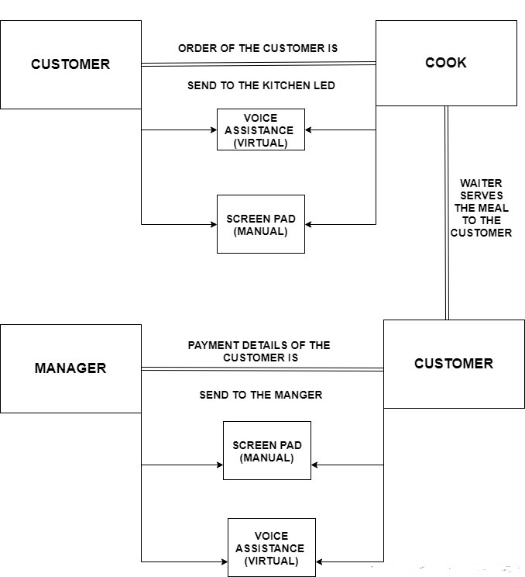

21. Develop test cases for a simple calculator program.

TC_06 | Multiplication of two positive numbers | 6 * 7 | 42
TC_07 | Multiplication with zero | 8 * 0 | 0
TC_08 | Division of two positive numbers | 10 / 2 | 5
TC_09 | Division by zero | 5 / 0 | Error: Division by zero
TC_10 | Division resulting in a decimal value | 7 / 2 | 3.5
TC_11 | Handling invalid operator | 4 % 2 | Error: Invalid operator

22. Document a real-world case where a software application required critical maintenance.

Ans.
​ A real-world example of a software application requiring critical maintenance is the Federal Bureau of Investigation's (FBI) Virtual Case File (VCF) project. Initiated in 2000, the VCF aimed to modernize the FBI's outdated case management system. However, by 2005, the project was abandoned after costing nearly $170 million, primarily due to inadequate design and incomplete development. ​

Background
In September 2000, the FBI launched the "Trilogy" program to upgrade its Information Technology (IT) infrastructure. This initiative had three components:​
- Providing modern desktop computers to all FBI offices.​
- Developing secure high-performance Wide Area Networks (WAN) and Local Area Networks (LAN).​
- Modernizing the FBI's suite of investigative software applications.​

Challenges and Failures
The VCF project encountered several critical issues:​
- Lack of a Strong Technical Architecture: The absence of a clear blueprint from the outset led to poor architectural decisions.​
- Frequent Specification Changes: Continuous alterations in project specifications hindered consistent development progress.​
- Management Turnover: The project saw rapid changes in leadership, contributing to instability and shifting priorities.​
- Scope Creep: The project's scope expanded continually, adding complexity and contributing to code bloat—at one point, the software had over 700,000 lines of code.​
- Deployment Strategy: The plan for a flash cutover deployment made it difficult to adopt the system incrementally, requiring perfection before rollout.​

Implications
The failure of the VCF project had significant implications:​
- Financial Loss: Approximately $104 million in taxpayer money was lost.​
- Operational Inefficiencies: The FBI had to continue using the outdated ACS system, hampering its counter-terrorism mission.​
- Initiation of New Projects: In March 2005, the FBI announced a new software project, code-named Sentinel, to replace ACS. After several delays and adopting agile software development methodologies, Sentinel was completed under budget and deployed agency-wide on July 1, 2012. ​

This case underscores the importance of robust project management, clear technical architecture, and adaptability to change in large-scale software maintenance and development projects.

23. Create a DFD for a hospital management system.

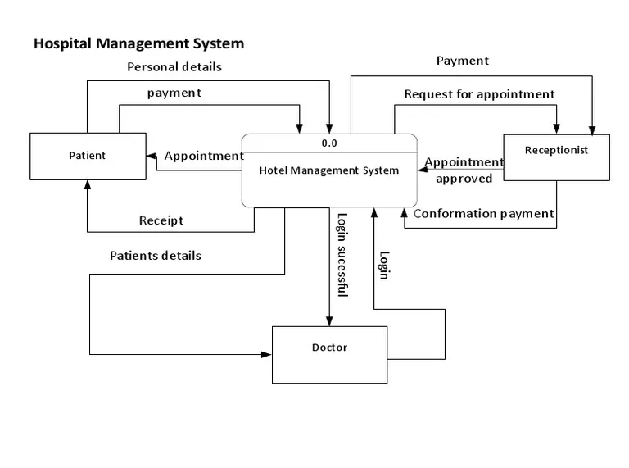

24.Desktop calculator application using a GUI library.

#include <iostream>

using namespace std;

int main() {
double num1, num2;
char op;

cout << "Enter first number: ";
cin >> num1;
cout << "Enter an operator (+, -, *, /): ";
cin >> op;
cout << "Enter second number: ";
cin >> num2;

switch (op) {
case '+': cout << "Result: " << num1 + num2 << endl; break;
case '-': cout << "Result: " << num1 - num2 << endl; break;
case '*': cout << "Result: " << num1 * num2 << endl; break;
case '/':
if (num2 != 0)
cout << "Result: " << num1 / num2 << endl;
else
cout << "Error: Division by zero!" << endl;
break;
default: cout << "Invalid operator!" << endl;
}

return 0;
}

25. Draw a flowchart representing the logic of a basic online registration system.

